**Bug on Page ‘www.bonify.de​’:**

**Issues 4:**

Text (Header) is not fully converted to EN (Convert DE to EN).

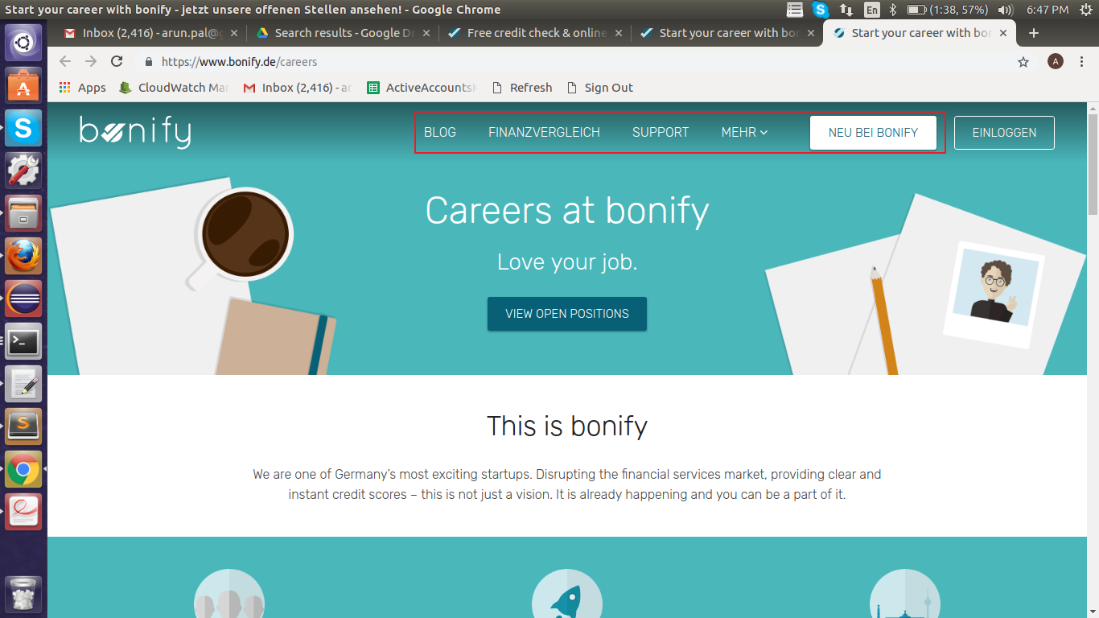

**Steps To Reproduce:**

1: Start Chrome Browser with url **‘https://www.bonify.de/careers’.**

2: Observe the Page, Header section is not converted in EN.

**Note -** In Many pages I found Text is not fully converted into EN.

**Expected Result:** When the site is converted to EN all the text, header, footer should be displaying in english.

**Actual Result:** Site displaying header, text and other options in DN although its converted to EN.

**Browser:** Chrome (Version 70)

**OS:** Ubuntu (16)

**Priority:** P1

**Assign To :** Developer.